1. What is different to current techniques? Why is this better? Which gaps does it address?

* what types of data are you going to collect
  + which of these are already used in current models, which not?
  + how do these strengthen current models?
  + which of these types of data could also be collected from video, which not?
* How can we collect more data (and relevant data) via mobile phone as opposed to video?
* How about real time data? Is there a chance to collect data in a real emergency situation where video cannot be set up in time.
* “Continuous” data collection in everyday situation can generate vast amounts of data

1. Regarding methodology, how can this be done?

* technically? how would it work?
* “socially”: how do you deploy it? How do you get people to participate?

**MACHINE LEARNING** allows to predict next destination, next behaviour based on past, training dataset/ testing dataset. Optimisation is a heart of Machine Learning since it allows resolving constraint/ convex problem (maximize, minimize). **Machine learning can’t apply at all in crowd modelling since it can’t explain why a behaviour is chosen (decelerating, or accelerating), more features or more complicated output classes are difficult to design.** This study aims to utilize combinatorial optimization techniques and machine learning to find ‘human-like’ route choice behaviour and generate effective evacuation plan.

**Machine learning can’t create evacuation plan for each people. Because it depends on training/dataset predict next location. However, people change their locations, even in current position they also re-route, detour, ML can’t help to predict location of re-routing, this work is happend simultaneously and don’t depend as usual pattern. Evacuation modelling must be stochastic problem optimization.**

**AI** is a wide range illustrate intelligent agent, it covers machine learning/ optimization/ and modelling, operational research.

In the **deterministic user equilibrium (DUE) problem**, a simple route choice model assumes unrealistically that travelers have perfect knowledge about path costs and choose the route that minimizes their travel costs. In the **stochastic user equilibrium (SUE) problem**, a probabilistic route choice model assumes reasonably that travelers have imperfect information about path costs and choose the route that minimizes their perceived travel costs given a set of routes. In **dynamic traffic assignment (DTA)**, a route choice model is either predetermined or computed while the network loading mechanism operates.

From the movement of pilgrims in Mecca to rioters in the streets of London, crowds display fascinating patterns; crowd is not only the gathering of people.

The real power of agent-based modelling and simulation is its potential to reveal some counterintuitive collective system level behaviours when all individuals appear to make rational decisions at the individual level. This type of counterintuitive system level behaviour may differ from one location to another, and vary from one culture to another.

Other survey in cognitive force based model

It can emphasize the effects of different individuals (Nuria Pelechano & Norman I Badler 2006; Braun et al. 2003); it can stress the importance of the intelligence of individuals (Davidsson 2001; Macal & North 2007; Stefania Bandini et al. 2007; Seidel et al. 2008; Stefania Bandini et al. 2009; Bonabeau 2002; Shendarkar et al. 2008; Sung et al. 2004).

Challenge1: design a homogeneous crowd model to reduce complexity at the beginning

Challenge2: this approach can model the resultant group behaviours of a crowd based on social psychology findings. It has been found that individuals could lose their individualities and adapt their behaviours to those of the whole crowd (Soraia Raupp Musse et al. 2005; Heïgeas et al. 2003; Stoot & Stephen Reicher 1998; Villamil et al. n.d.). The simulation of a homogeneous crowd can successfully produce similar crowd behaviours to those social psychology findings. Pelechano and Badler (2006) introduced the leader role into a crowd and showed that the crowd could have different group patterns. Shendarkar et al.’s study (2008) showed how policemen could affect the choices of escape routes by individuals during fire excavations.

First point: It enables individuals to make independent decisions in the same situation, which means individuals will act accordingly to their own interests and abilities

Second point: Variances in individuals conducting a same behaviour due to the differences between them, i.e. a behaviour may be performed slight differently by individuals.

Crowd Monitoring by Camera or Mobile Sensing limitations: couldn’t provide socio-psychological explainations for dis order, or not directly testable, reproduce the phenomena, assess dynamic environment, or understand relationship. Simulation provides a mean to test theory and analyse complex social systems.

Social Force Model limitation:

The motion formulas proposed in the force-based model are applied to every individual. Computational burden. Local route choice

CA limitations:

In CA model, the existence of individuals is indicated through the cell states and the individual movement is determined by the states of the neighbouring cells. Homogeneous speed of the crowd. Fixed cell sizeFixed maximal crowd density (when every cell is occupied), The cells may not totally align geometrically with the fields, Homogeneous individual body size, Lack of individuals’ characters.

The CA model only represents the positions of individuals and ignores their characters.

Fluid dynamics

is the subdiscipline of fluid mechanics that deal with fluid flow, fluid dynamics describes the continuum, continuous rather than discrete. Fluid dynamics normally has two types of itself aerodynamics and hydrodynamics. **Aerodynamics** is the study of air and other gases in motion whereas hydrodynamics studies liquids in motion such as water. **Hydrodynamic** model is the set of equations describing motion of fluids especially the action of force applied to the fluid. Hydro dynamic’s equation is derived from Newton Laws equation. (Navior-Stokes).

<http://www.nauticalcharts.noaa.gov/csdl/learn_models.html>

**Crowd Modeling Approaches**

How we can create mathematical models and run computer simulations of pedestrians?

Modeling of pedestrian motion is performed for different reasons: to quantitatively investigate evacuation dynamics, to assess public facilities, or simply to gain more knowledge about how pedestrians interact with each other and how the design of the different infrastructure affects the flow of pedestrians, relationship human and biology, and **find parameters to track monitoring**. Crow research tries to understand crowd phenomena. It helps to know more about pedestrian and put him in differenet infrastructure rather than in fixed infrastructure (that can use by Machine Learning/ pattern recognition to predict route)

**Crowd Dynamics:**

* Crowd dynamics infers to the large-scale emergent behavioral patterns that could be complex large-scale spatio-temporal of motion in **high density**. Self-organized emergent behaviors on a macroscopic level.
* Crowd density, crowd flow, mobility graph, and relative density time series in large-scale, city scale.
* Read more about evacuation dynamics in the paper [8], [9]

**Crowd modeling arguments**

* Flow-Density:
  + Flow rate: Pedestrians per meter per second.
  + Crowd density: pedestrians per square-meter.
  + Effect of body-size
  + Motion characteristic: is the motion of pedestrian mainly the same direction
  + Psychological factors: crowd is stress, relaxed, panic.
* Local Density, Speed, Flows of each pedestrian by formulas in [2, page 62]
* Macro quantities (density, flow, velocity)

**Crowd Parameters:**

|  |  |
| --- | --- |
| **Levels** [5] | **Parameters** |
| Macro scopic | Crowd Density |
| Mesco scopic | Collective behavior recognition  Flock, group detection  Lane & queue, flow detection  Onset of panic |
| Micro scopic | Parameters of individuals  Modes of locomotion  Velocity, Direction, Gesture, Position,Trajectory |

**Crowd Forces Collection**

**Mobile Sensing Crowd Modeling Introduction**

It was difficult to find any commercial or free software that was flexible enough for our needs in capturing mobile sensing data in large-scale and real-time towards crowd modeling.

**Video-based approach for crowd modeling on Micro, Macro scales**

Models that consider the simulation environment as a two dimensional continuous space and perform the simulation in small time steps are usually called microscopic [1].

Models that still represent individual persons but rely on a coarser abstraction of the real world or often called mesoscopic [1].

Macroscopic models only use densities or groups of persons [1].

**The motivation for using three different approaches** is that for microscopic validation and calibration of microscopic models, reliable trajectory data are needed. On the other hand, for online monitoring of crowds, it is a requirement that the algorithm can process the videos in real-time [2]. Macroscopic approach is that the video analysis can be made on arbitrarily long time scales of days or even longer, since no human interaction is needed during operation, it is appropriate for segmenting global patterns of flow. Others might call for descriptive information on when the behavior of a crowd is abnormal. It means to understand how groups of individuals interact.

Video Micro-based approach:

The aim is to determine accurate trajectories of the pedestrians from crowd videos. A video file is loaded, the user selects an origin and an x and a y axis. The user marks the diameter of a head, for reference. The user clicks at each new (unmarked) head on the screen. The user presses a button to progress the video one time step, the computer tracks all heads from the previous frame to the new frame.

Macro-based approach:

This full automatization only holds when the video-analysis is in operation. It still needs some manual user interference in the initial calibration phase. One extension of the video-analysis method presented in this section is that the method will not only track the pedestrians, but it will also identify new persons once they enter the video. The idea behind the software is that it will automatically determine heads by searching (by filtering method, or AI, pattern recognition).

**Limitation in video-base analysis:**

* Just security video, raise alarm if pedestrian were being identified in certain zones, no features to track pedestrian motions once they were identified
* Just is setup for dozen pedestrians but not for hundreds of pedestrians
* No possibly to interact and plug additional self-developed modules to identify new kinds of measurements.
* Not automated enough. Terabyte of material is distributed, not possibly to manually load each file and set up. [2]
* the computational cost of video analysis limits the scale at which experiments can be run, cameras
* can be affected by complications such as occlusion and incomplete coverage, and privacy issues
* can emerge when the footage is recorded from real world events [6]

**Advantages of using Mobile as another supplement solution**

Smartphone apps can be used to infer a good approximation of crowd behavior at large scales, and can be used to pro-actively intervene before crowds reach critically high density levels

Broadband-communication allows to capture, transmit and centrally process data in near real-time and to extract and visualize relevant crowd parameters in a command and control center

Offering bi-directional communication, safety personnel can send notifications, warnings, or even guide the user in case of an emergency situation. Incorporating the user’s localization, geo-located messages increase the relevance for each user, helping to follow rules.

Data, once collected, can be used to “replay” the event. The post hoc analysis is a critical step in the organization of an event and can reveal critical factors that should be addressed for future events. Although today a great deal of data is available for such analyses, event organisers and crowd managers are sometimes forced to manually scan through video material, reports from security services in the field, or feedback from individual visitors [5]

**Agent-based Models:** These models are characterized by a high level of autonomy of the simulated pedestrians, where each pedestrian is controlled by a set of rules.

Advantages: the motion is look very realistic, the agents can be adaptive and possess high degree of artificial intelligent, suitable for animation.

Disadvantage: tends to be complicated, hard to approach analytically, computational effort.

Agent-based support tools support the planning but are rarely data-driven and are not able to compare simulation results with actual crowd behavior in posthoc analysis. However, posthoc analysis is the first important step of organization an event and can reveal critical factors that may be addressed in future events [7].

**Social-force Models:** micro scopic model, which is continuous both in space and time. It is influenced by Newtonian mechanics, generalized to the motion of pedestrians.

**Collective Behavior in Panicked Condition**

With the increasing size and frequency of mass events leading to more often crowd disasters, the study of collective behavior of panicked crowd has become important research area. However, even successful modeling approaches are hard to calibrate since the dynamics of crowd is sensitive to changes in the model. Probably, the only way to calibrate the model is to compare the results of computer simulations with scenarios of real events giving the most comprehensive empirical data [3].

Emergency evacuations during the past decade have transitioned from landline analog to mobile digital communication devices. Over 88% of US citizens own a mobile phone, providing a tool to enable better communication between ﬁrst responders and citizens in order to minimize risk to evacuees during no-notice evacuations. During an emergency, evacuees rely on social media to communicate with family, friends, and coworkers, often ﬁnding accessibility to social media more reliable than trying to make a phone call. Federal, state, and local emergency operations centers have made limited use of social media or Internet-based communications to provide an alternative means for citizens to request assistance or provide information. Mobile devices provide an alternative method of incident reporting and analysis through volunteered geographic information (VGI), which ﬁrst responders can use to minimize risk to evacuees [4].

**Crowd Disaster Concept**

Crowd disasters are examples of situations in which people are killed by other people, even though typically nobody wants to harm anybody [5].

Extreme events may lead to an emergent collective identity that will result in increased solidarity with strangers rather than the opposite.

Crowd Disaster terms ‘crowd crush’, ‘panic condition’ – psychological, crowd turbulence.

**REAL-TIME DATA ACQUISITION FOR ADAPTIVE CROWD MODELING**

**CHAPTER1: Introduction (20000 words)**

+ **Important of crowd modelling** by mobile & camera approaches [understand evacuation dynamics[read papers about **evacuation dynamics, panic & disaster management**], behaviour, design architecture especially in right corner through publications –sarvi, in helbing 2014 saving, simulation]. Evidence to show crowd disaster.

+**Why we need both of Camera & Mobile data**

* Mobile proximity can detect exit, enter, dense city-scale, waling group independent, speed, steps. GPS only for active data with has significant outdoor position
* We still need camera because:
  + Crowd people same behavior but not in the same flow. Which flow current user in
  + Interaction force between people, neighboring force
  + Perform understand distance, cognitive process –determine obstacles,
  + Crowd disaster indoor, understand layout architecture to design, corner, impacts of pedestrian evacuation
  + Detect flock but flow is more important, flow movement direction, uni-bio cross flow direction

+ **Research Question**

1. What information is indeed important for crowd modeling? (crowd flow monitoring, crowd density from survey paper, Dirk Helbing in flow corner and density know density to prevent, savi detect flow in conner, survey paper indicate that other publications have limitation in self-phenomena detection, crowd abnormal behavior as on Visual Crowd Surveillance through a Hydrodynamics Lens)
   1. which of these are already used in current models, which not?
   2. how do these strengthen current models
   3. which of these types of data could also be collected from video, which not?
2. How can we collect more data (and relevant data) via mobile phone as opposed to video?

3. How do we collaborate to these sensors and manage effectively? Adaptive new data from current flow, features

4. What if one of them is died & how to infer

5. Bigdata and how to get those information real-time but effectively (*read again papers in data accquisiton_optimisation*)?

+ **Other questions**

*In high-density conditions:*

**Q1**: Which area could lead to high crowd pressure and at what time when we know pedestrian’s current location and frequent route? This question can help us know pressure changes of an area during a duration and pressure-transition-based relation of areas in different  intervals. If a cell are gaining an extraordinary pressure comparing its normal pressure, it should be investigated for infrastructure quality early. Defining a cell length is also a subquestion. The pressure transition-based relation is used to make evacuation plan avoids potential high- pressure-locations from disaster areas.

**Q2**: Where and when high-dense lanes could be formed and their expected density based on pedestrian’s habit path (location-time)? What is the historical distribution of displacements, and correlation coefficient between average speed over a period? This information is to investigate the lane creation between two cells has higher density and velocity or earlier than its normal characteristic for giving early warnings.?

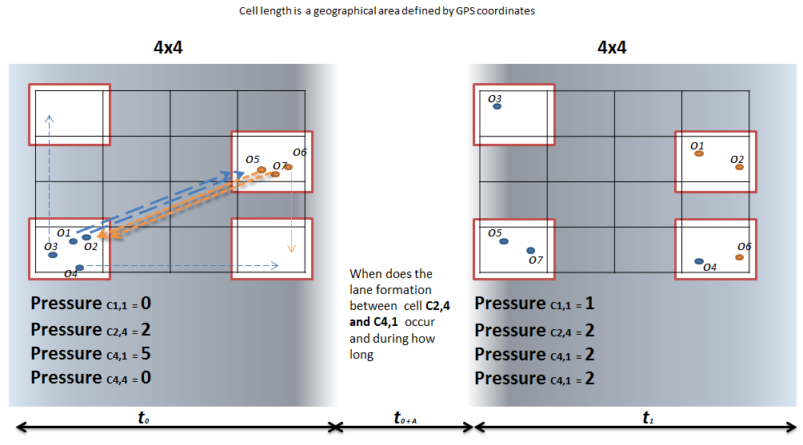

+**Aims**:

* Broadband, utilize, propose novel crowd parameters capturing acquisiton, exhaustive micro to macro. How the information can work together
* user bigdata architecture storage, can replay event, store key information not raw video so that we can validate data, real time day by day
* biodirectional communication on evacuation
* Comperative utilities crowd parameters infer panic condition, avoidance

+**Methodology & scope & architecture of our thesis**: focus on high-density crowds. (what is high-density: talk about papers with 6-7 pedestrians/m2 from Helbing)

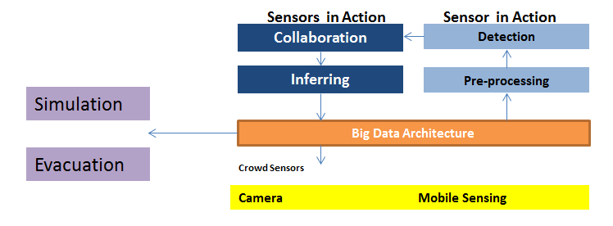

Fig.1 Collaboration between sensors

Inferring with historical data, as well as knowledge proceeded in the past (from human, biology)

+ Dataset: GPS, high-density crowd in Mentosa University & our video information. Talk about these publication

+ Tool for simulation + biology inference

**CHAPTER 2: LITERATURE REVIEW (30000 words)**

+Overall through survey papers on high-density crowd & biology inference

+Analysis and studies in micro

+Analysis and studies in meso

+Analysis and studies in macro

+Efforts in crowd disaster data generally

+Approach by biology swarm

+Approach by panic detection

+Approach by smart phone & context-aware framework

+Approach by survey & calibrate + validation simulation

**CHAPTER 3: Data Acquisition on MICRO scopic in high-density + Optimisation**

**CHAPTER 4: Data Acquisition on MESO scopic in high-density + Optimisation**

**CHAPTER 5: Data Acquisition on MACRO scopic in high-density + Optimisation**

**CHAPTER 6: Combine data from Mobile & Camera in proposed architecture**

**CHAPTER 7: CONCLUSION & FUTURE WORK**

**REFERENCE**

[1] 2013_Large-scale and microscopic a fast simulation approach for urban areas

[2] 2009_Data Driven Model of Crowd Pedestrian

[3] 2014_Panicked Collection

[4] 2014_Mo-Notice Urban Environment Evacuations Using Crowdsourced Mobile Data

[5] 2014_Saving Human Lives What Complexity Science

[6] 2014_Sensing the Texture of a crowd final

[7] 1014_Capturing crowd dynamics at large scale events

[8] Simulation of pedestrian dynamics using a two-dimensional cellular automaton. (Burstedde, Schadschneider, 2001)

[9] Simulation evacuation processes using a bionics-inspired cellular automation model for pedestrian dynamics, 2002.

----------------------------------------------------------------------------------------------------------------------------------------

Style of Abstract for Presentation

Influenza is a major public health concern as it causes significant morbidity in the population at large and mortality in the very young, elderly and in persons with chronic illnesses. The 1918-1919 Spanish flu and 2003 SARS pandemics are stark reminders of the potential consequences of infectious diseases. Although the SARS epidemic was not the world-wide pandemic that scientists feared, it still managed to spread to nearly every continent on Earth. This clearly points out how crucial it is to understand how, when and why epidemics spread across the landscape so that effective planning, preparation and control measures can be in place before a disaster occurs. Geographic models can help us understand the spatial spread from the epicentre and the rate at which the disease diffuses from the epicentre. This will then inform control strategies like contact tracing and quarantine during the initial phases of the outbreak and ring vaccination or some other control strategy at later phases of the epidemic. In the light of this, I will briefly review some of the mathematical, computational and network models from the literature which implicitly or explicitly consider space and the assumptions these models make. I will also review the applications of some spatio-temporal models successfully implemented. And finally conclude with, how these applications motivate the early framework for my project which is also strongly informed by a field study conducted in Melbourne where data has been collected at the individual level of granularity. With the proposed framework I hope to investigate how seasonal Influenza spreads in Melbourne.

Disaster occurs in … latest evidences. Although modelling inferring,, and simulation ,,.. have studied and applied popularly on camera video. But the approach was face by limitation of … Mobile approach became alternative solution relying on its robust sensing and maintain communication during and post disaster for supply chain demand. However, there are problems that haven’t yet resolved on ..This clearly points out how predict pre-disaster and make evacuation plane become more effective from mobile phone data. This will then inform control strategies and quarantine initial phases of the outbreak. In the light of this, I will briefly review state of the art in crowd modelling research and point out essential gaps and review successfully implemented related works achievements that implicitly and explicitly are considered for the gaps. And finally section is our early framework for my project which strongly informed by data collected continuously in Melbourne.

With the rapid development of computing and networking technologies, the miniaturization of sensors, and

the introduction of smartphones, a range of new ways to capture data on people’s movement have become available

in recent years with potential to supplement and extent the classic methods

STATE OF THE ART  
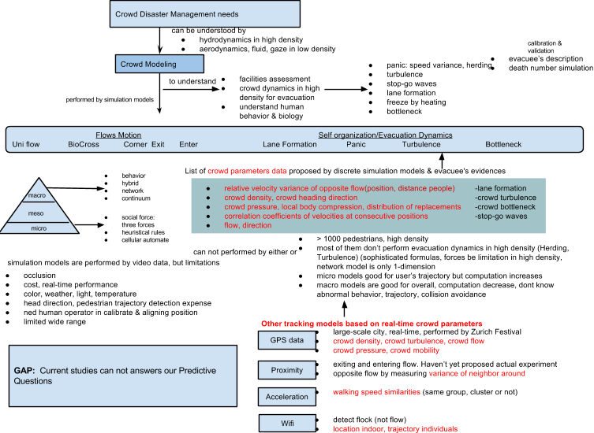

**II. RELATED WORKS for Questions 1 & 2 & 3**

Temporal approach that studies human behavior during a duration is explored on various sources including proximity and GPS information as following newest achievements:

**TABLE I**. **Temporal information-based studies**

|  |  |  |  |
| --- | --- | --- | --- |
| **Author**  **published year** | **Approach** | **Purpose** | **Description** |
| Vedran Sekara  -2014- | Mutual relation | Study the strength of friendship via Proximity Sensor Data during 119 days.  The collected data measured surrounding devices of each volunteer via Bluetooth signal strength | A network was constructed by 134 nodes and more than 2 million edges. Links are categorized by weak and strong in which weak links are identified when they have been observed on average less than one per day. A Bluetooth threshold is found to maximize the number of removed weak links, while minimizing the loss of strong links. The raw network with strong and weak links are then proceeded into three other types:  Thresholded network: Remove links under the threshold  Null network: Remove the same number of links but the links are chosen randomly (the procedure is statistic averagely over 100 times).  Control network: Strong links are removed at the threshold to check social proximity in fact (Facebook social).  Above networks are compared under several standards:  -Removed Link’s reappearance probability  -Quality of removed link via proximity(average weight of removed links over average weight off all links)  -Quality of Facebook link removed (online friendship status).  The paper finally found that the quality of removed links in Control network is highest. However, identifying actual relationship should be studied more by other aspects. |
| Xuan Song  -2014- | Human’s Mobility | Predict human emergency behavior and their mobility following disaster. The data were used  over one year on the stages before, during and after Japanese Earthquake. | A HMM was constructed to perform the relationship of human emergency behavior and influenced factors (social relationship, intensity of disaster, damage level, large population flow, news report). Given the current state of disaster and these factors, predict human behavior at next step.  A mobility graph was created to answer the question, given the predicted places where individual person will go and its current location after disaster, predict its possible movement route to visit next locations  since transport networks had been destroyed. This work is important for evacuation plan picking up evacuee on time at right place. |
| Andres Sevtsuk  -2010- | Human’s Mobility | Study on whether urban mobility have a daily routine |  |
| Other studies about Erlang values and Japanese urban planning |  |  |  |

Both of above studies are valuable on understanding how graph model works based on temporally extracted information and the influence of disaster news, and relevant factors impact on human behaviour  during and post- disasters happened. However in our study, we focus on investigating crowd pressure transition through cells and lane formation on edges based on temporal human mobility data and velocities on vertices and edges over a period. This work is to address **Q1**, **Q2, and Q3**.

**In Australian research community**

Understanding spatial-temporal information of public transports underpins the development of contemporary urban environment. It involves various research approaches including infrastructures, networks, modelling, road safety, logistics, travel behaviour changes, walking, bicycling, etc (* ATRF Forum). Models analyzing GPS data on temporal dimension are applied on following applications:

1. Using scats Data to Predict Bus Travel Time (* Sarvi-2012)
2. Mining temporal and spatial travel regularity for transit planning (*Edward Chung -2013)
3. Analysis of Child Diaries - Can GPS Traces of Parents Movements Provide Sufficient Travel  Data for Children (* Christine Prasad -2012)